
A10
Sreenidhi Institute of Science & Technology
(An Autonomous Institution)
Code No: 101EC08/111EC08

B. TECH. II – Year I – Semester Examinations, Dec/Jan 2015 (Supplementary)
SIGNALS AND SYSTEMS (ECE)

Time: 3 Hours Max. Marks: 70

Note: No additional answer sheets will be provided.

Part - A
Max.Marks:20

Answer all QUESTIONS.

- Define Energy and Power signals with examples.
- Draw the signal x(2t+3) if x(t) is as shown in below figure.

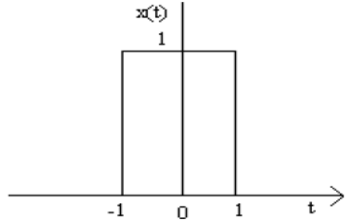

- Write a short notes on Hilbert Transform of the signal f(t).
- Find the Laplace Transform of x(t) = -e^{-at} u(t).
- Define Impulse Response and Transfer function of LTI System.
- Write any three properties of correlation.
- What is Bandpass signal sampling? Explain briefly.
- Write the conditions for ROC of H(z) for the system to be causal and stable.
- Check whether the system defined by the equation y(t) = 2x(t) is linear or not.
- Write the properties of convolution.
Part – B
Max.Marks:50

ANSWER ANY FIVE QUESTIONS. EACH QUESTION CARRIES 10 MARKS.

1. a) Prove that the set of signals {sinnω₀t, cosmω₀t} are mutually orthogonal in the interval (t₀,t₀+2π/ω₀) [4M]

b) Find the Exponential Fourier series for the full wave rectified Sine wave as shown in below figure. [6M]
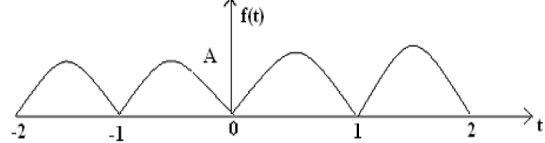

- a) Explain the Convergence of Fourier Series with Dirichlet conditions. [4M]

b) Find the Fourier Transform of
i) Gate function
ii) Unit step function
with suitable diagrams [6M]

3. a) State and prove the following properties of Fourier Transform
i. Differentiation in time domain
ii. Convolution in time domain

b) Consider a stable LTI system that is characterized by the differential equation

Find its response for input x(t) = e^{−t} u(t) using Laplace Transform.

4. (a) Explain Causality and physical reliability of a system and hence give Poly-Wiener criterion.
[4M]
(b) Obtain the relationship between the bandwidth and rise time of ideal low pass filter. [6M]

- a) Briefly explain about the detection of periodic signal masked by the noise [6M]

b) Find the convolution between x(t) = e^{−2t} u(t) and y(t) = e^{−4t} u(t) [4M]

- State and Prove the sampling theorem for band limited signals

- a) Find the Inverse Z - Transform of the following

X(z) = (2z-7)/(z²-5z+6) with ROC |z| > 2

b) State and prove the initial and final value theorems of Z – Transform.

8. a) Distinguish between natural sampling and Flat top sampling.

b) Derive the relationship between energy spectral density and auto correlation function of a given signal.

-- 00 -- 00 --

